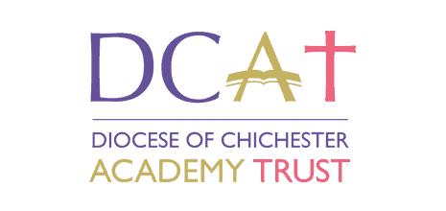
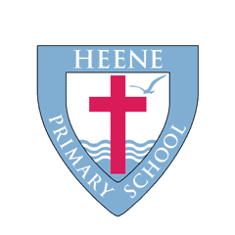
Religious Education policy

Date agreed | 03/2026
Review date

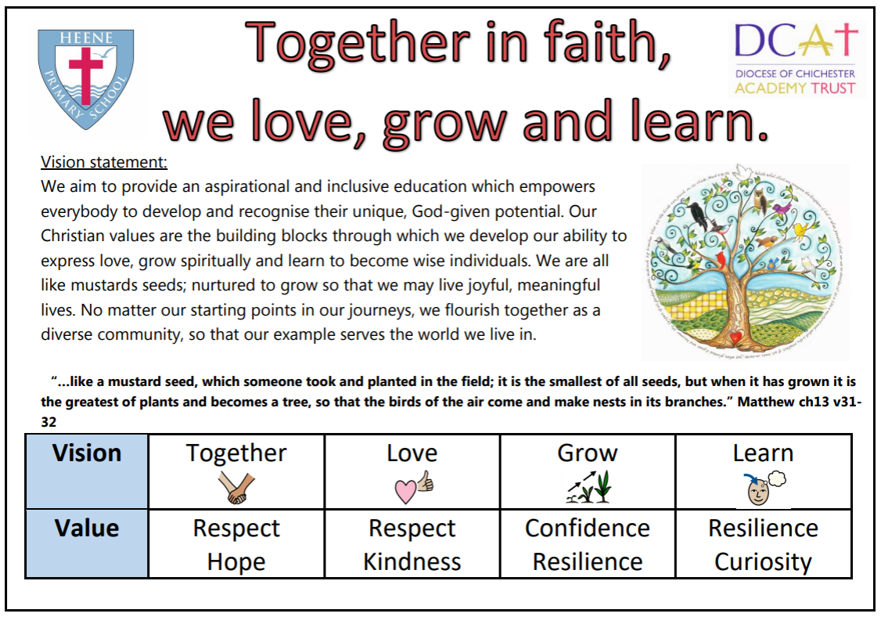
“What no eye has seen, no ear has heard, and what no human mind has perceived the things God has prepared for them.” 1 Corinthians 2:9

Intent
Heene Church of England Primary School strives to ensure all children achieve their God given potential where ‘Together in faith, we love, grow and learn’. Our RE curriculum is part of the vehicle through which we demonstrate our vision in action through our core values (respect, curiosity, kindness, resilience, hope and confidence). As a distinctively Christian school, our aim for Religious Education is to develop children’s understanding and beliefs on what it means to live out a truly meaningful life guided by God. We respect each child as an individual and encourage children to develop their confidence to share their own deeply held beliefs and ideas with their peers. Our RE curriculum focuses on a range of religions and worldviews which reflect the diversity we have in our school community (50& Christianity and 50% other world religions). We foster community and collaboration so that learning and respect can be achieved together, whilst building positive relationships both inside and outside the classroom. We provide children with opportunities to reflect on their own beliefs and values and encourage them to think critically about the world around them so that they can grow spiritually and morally. Kindness is developed through children becoming courageous advocates and using their learning to make meaningful changes in the local and wider community that express their hopes and desires discovered through the process of their learning. They will become lifelong learners who are hopeful, resilient and have the confidence to express their own belief system, moral compass and understanding of the world around them. Learning also takes places outside of the classroom so that children gain a unique perspective into the cultures of others and explore the core beliefs of global living faiths. Their curiosity is fostered through unpicking, answering and debating life’s Big Questions within a creative, reflective, purposeful and ambitious RE curriculum that excites children through awe and wonder.
Impact
Children develop a sense of identity and belonging by exploring different faiths and worldviews. It encourages them to ask big questions, think critically and show respect for others, building the foundations for empathy and positive relationships in our diverse society.
Aims
Our aims for Religious Education at Heene Primary are as follows:
- Gain knowledge of a wide range of religions and worldviews
- Appreciate diversity towards different world views and faiths
- Learn about religion as a global living faith which is ever changing
- Explore core beliefs key to each religion
- Recognise core beliefs as a reason for social norms/change
- Engage with challenging questions of meaning and purpose through reflection
- Appreciate and develop spirituality
- Recognise the concept of religion in the lives of individuals and societies
- Explore religious, spiritual and philosophical ways of living, thinking and believing
- Children to become ‘RE specialists’
- To learn about religion and to learn from religion

Religious education status at Heene Primary
RE is an important subject at Heene Primary and has a core subject status and high profile within our curriculum. 45 hours of the school calendar year are dedicated to RE teaching and learning for Key Stage 2 children and 36 for Key stage 1 children. These allocated hours are separate from time spent in Collective Worship however connections exist between the two.
Schemes of work
In line with the Church of England statement of entitlement, 50% of teaching and learning focuses on Christianity with the other 50% being on other religions and comparison study. We make use of Understanding Christianity for modules on Christianity, and we use the Emmanuel Project as the basis for modules on other religions. We also make use of the Big Frieze to study Christianity topics in order to place them within the big story of the Bible. All are adapted with our children in mind to achieve our impact statement. Any necessary adjustments are made in line with West Sussex West RE Syllabus which we have adopted.

Implementation
We make use of an enquiry approach within our RE teaching and learning. Each module revolves around a central ‘big question’ which pupils respond to at the end of a topic, with a series of smaller enquiry questions as assessment points for individual lessons (appendix a & b).
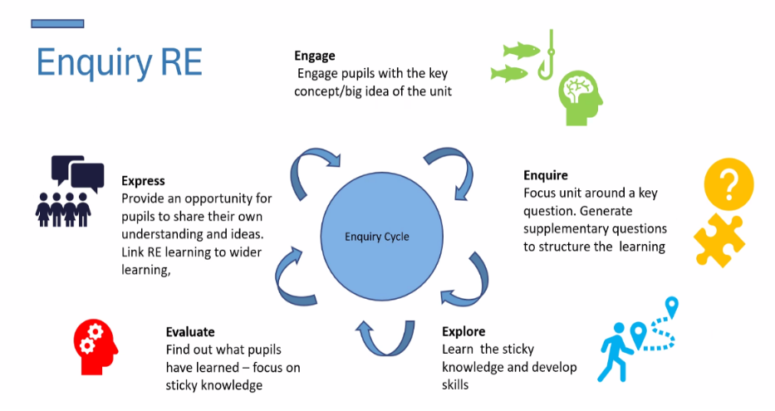

A spiral curriculum has been organised with levels of both horizontal and vertical progression across a range of faiths. In the final term, new content is introduced and children use their comparison skills to compare previously taught topics to answer their enquiry question.
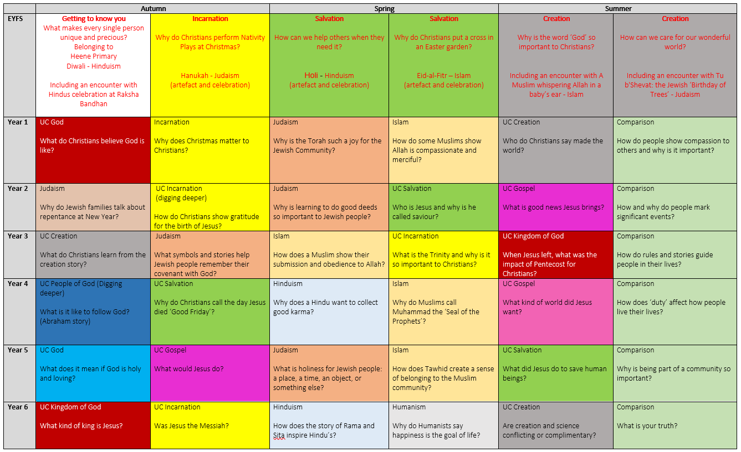
Questioning within lessons forms the basis of teaching and learning within Religious Education at Heene primary. When planning RE, our question matrix is used to ensure an enquiry approach towards RE is used with a key focus on oracy. ABC sentence stems are used to encourage whole class discussion between members of the classroom.
In every lesson, children will be given the opportunity to reflect on how the learning of religious beliefs, practices and ethical questions apply to their own lives by answering a reflection question. These are not a challenge, but a fundamental part of the learning process.
In line with our policy on Teaching and Learning, retrieval takes place at the beginning of all lessons, so that new learning can be built on in small steps.
Knowledge organisers are used throughout all topics. These provide stimulus pictures that cover key parts of study to generate discussion and the tier 2 and 3 vocabulary that is covered within the topic. Teachers encourage children use these and refer to them throughout the topic studied.
To make religious education a lively, active subject, we employ a variety of teaching methods including art, music, discussion, the development of thinking skills, drama, the use of artefacts, pictures, stories, and the use of periods of stillness and reflection in every lesson to encourage spiritual growth. Where possible, we want our pupils to have opportunities to encounter local faith communities through visits to local places of worship or visit from members of local faith communities.

We recognise the unique power of cultivating awe and wonder and curiosity within Religious Education. We begin each topic with a key religious story and use Godly Play for most of our Christianity topics. High‑quality artefacts such as sacred texts, ceremonial objects, clothing, symbols, or items associated with worship and celebration are used intentionally to deepen pupils’ engagement and understanding of diverse faith traditions whilst developing respect. Looking at examples of religious artwork is found in every year group and all children create their own piece of art to express their learning and point of view at the end of each topic.
Assessment in RE
Assessment grids are used to assess substantive knowledge (believing, social living and thinking) studied within a topic of learning and all pupils complete these during the retrieval stage based on the key enquiry questions planned for. Disciplinary knowledge is assessed through how children have engaged with the enquiry approach throughout a topic of work with key skills being focused on within a specific topic. Reflection questions, as well as responses throughout a topic, are then used to assess the children’s personal knowledge and how their learning impacts their believe system, values, ethical opinions and personal worldview.
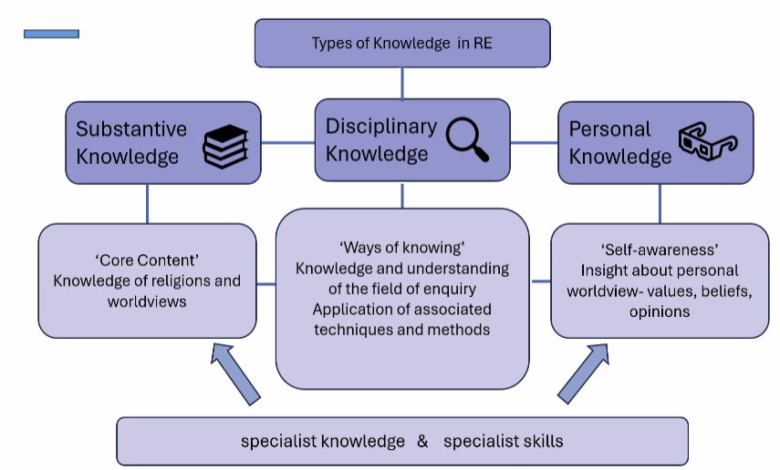
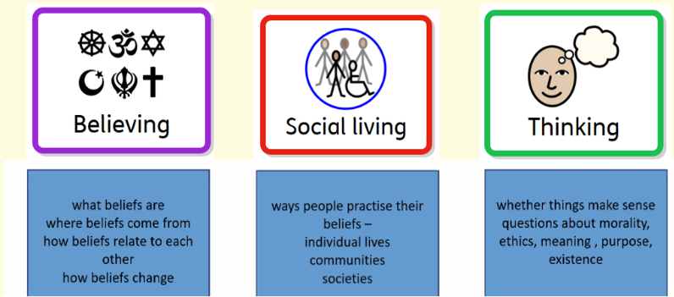
Inclusion and Equal Opportunities
RE has an important part to play as part of a broad, balanced, and coherent curriculum to which all pupils are entitled. We believe that it is the right of every child to receive Religious Education and as such all pupils are offered the opportunity to explore and engage with religious experiences, enabling them to grow spiritually and find meaning in their own way.

We recognise the fact that all classes in our school have children of widely differing abilities, and so we provide suitable learning opportunities for all children by matching the challenge of the task to the ability of the child. We achieve this by setting common tasks which are open-ended and can have a variety of responses and mediums used to convey learning and expression. Children are encouraged to draw, verbally communicate, express and write their ideas when suitable. Adapted resources are used, such as scaffolding and sentence stems, when necessary to ensure all children can flourish in RE with pre teaching of vocabulary and targeted support.

Monitoring and subject development
The RE subject leader is responsible for the monitoring of Teaching and Learning of RE in Heene Primary School. They have the role of providing suitable training for existing and new members of staff across the school, informing them of current developments and direction for the subject through action planning. Books are moderated twice a year with feedback given directly to teaching staff. The Senior Leadership Team and RE subject leader also come together to discuss Religious Education action planning, monitoring and feedback. The RE subject leader is responsible for lesson observations, gaining pupil and staff feedback and these are conducted throughout the year.
The subject leader improves standards of teaching and learning through:
● monitoring and evaluating provision across the school
● taking a lead in policy development
● auditing and supporting colleagues in their CPD and provide coaching
● organising resources
● keeping up to date with recent developments through research, attending network meetings or courses
● meeting with other DCAT Religious Education leads to share and discuss best practice
● ensuring cohesion with the school ethos, vision and values

The right of Withdrawal from RE
Heene Primary School wish to be an inclusive community but recognise that parents have the right to withdraw their children from parts of RE on the grounds that they wish to provide their own RE. This RE provision will be the parents’ or carers’ responsibility.
If a parent wishes to withdraw their child from Religious Education, they should contact the headteacher. We would aim to arrange a meeting with the RE subject lead and Headteacher to ensure the needs of the child and parents are suitably met.

This policy will be assessed annually both in terms of its implementation and effectiveness. In reviewing the policy, the Governing Body will be mindful of the views of parents, students and staff through a variety of consultations.

This policy has been adopted by the Governors/Directors in consultation with the senior leaders, the RE leader, Teaching and Learning leader and teaching staff.

This policy should be read in conjunction with other policies.

Date of adopted…………………… Signed………………………………………………….
Chair of Governors

Date of review………………………. Signed………………………………………………….
Chair of Governors

Appendix a: Lesson breakdown with a term
Understanding Christianity |  | Emmanuel Project
Lesson 1 – Story exploration / response  The first session in RE should be dedicated to the key Bible story. Ideally, this is to be presented through Godly Play. Once the story is presented, children are given time to explore or respond to the story and respond in their books with their ‘wonderings’.  Exploring the story could take place through recreating the story, engaging in godly play, freeze frames, drawings, mind maps, labelling the key characters, discussion etc... A picture of the story being explored should be in their book, followed by their wonderings and a reflection question. |  | Lesson 1 – Story exploration / response  The first session in RE should be dedicated to the key religious story. Once the story is presented, children are given time to explore and respond to the story and in their books with their ‘wonderings’.  Exploring could take place through recreating the story, freeze frames, drawings, mind maps, labelling the key characters, discussion etc... A picture of the story being explored should be in their book, followed by their wonderings and then a reflection question.
Lesson 2 – Enquire, Engage, Explore  This should be the next step in the learning. Usually, this would be unpicking a key theme or focus within the story presented in Lesson 1. A reflection question should also be completed and stuck in their book. |  | Lesson 2 – Enquire, Engage, Explore  This should be the next step in the learning. Usually, this would be unpicking a key theme or focus within the story presented in Lesson 1. A reflection question should also be completed and stuck in their book.
Lesson 3 – Enquire, Engage, Explore  The next step.  Activity with a reflection question in their book. |  | Lesson 3 – Enquire, Engage, Explore  The next step.  Activity with a reflection question in their book.
Lesson 4 – Enquire, Engage, Explore  The next step.  Activity with a reflection question in their book. |  | Lesson 4 – Enquire, Engage, Explore  The next step.  Activity with a reflection question in their book.
Lesson 5 – Big Frieze  The fifth lesson is dedicated to placing the learning within the big story of the Bible. The matching piece(s) of artwork from the Big Frieze should be stuck in a double page spread in their books. Children should then annotate what they notice, making connections to the current topic and previous learning. A reflection question should be present at the bottom. |  | Lesson 5 – Enquire, Engage, Explore  The next step.  Activity with a reflection question in their book.
Lesson 6 – Artistic expression  This lesson is dedicated to allowing children to express their understanding and learning. This should be done artistically, either guided by the teacher through a specific type of artistic medium or free choice. The reflection question should always be: Why have you chosen to include certain things in your piece of Art? |  | Lesson 6 – Artistic expression  This lesson is dedicated to allowing children to express their understanding and learning. This should be done artistically, either guided by the teacher through a specific type of Artistic medium or free choice. The reflection question should always be: Why have you chosen to include certain things in your piece of Art?
Lesson 7 – Expression of ideas  In their final session, children answer a dedicated ‘Big Question’ and express their ideas, skills and knowledge and link this to the wider world. |  | Lesson 7 – Expression of ideas  In their final session, children answer a dedicated ‘Big Question’ and express their ideas, skills and knowledge and link this to the wider world.
Appendix b: Taken from RE teacher booklet on RE practice at Heene

Lesson 1: Story exploration
Engage
The first session in RE should be dedicated to a key story. Ideally, this is to be presented through Godly Play in Understanding Christianity topics. These however can be presented through story books, religious text reading, videos and drama. Once the story is presented, children are given time to explore or respond to the story and respond in their books with their ‘wonderings’.
I wonder…
Exploring the story could take place through recreating the story, engaging in Godly Play, freeze frames, drawings, mind maps, labelling the key characters, discussion etc... A picture of the story being explored should be in their book, followed by their response and a reflection question.

Lessons 2, 3, 4 (and 5 if Emmanuel Project)
Enquire, Engage, Explore
These are the main parts of the sequence of learning that allow for small steps to be made through dedicated small enquiry questions.
These should focus on a key theme presented within the story which is then explored through looking at religious beliefs, religious beliefs in practice, and the associated ethical questions of thinking about the world and our lives.
Lessons should be adaptive from the ground up which provides opportunities for children to discuss and evaluate their own ideas and the ideas of others. Activities should be engaging, creative, and fun with a reduced focus on writing to provide evidence of learning with open ended opportunities for expression. Pupil voice, however, should be present.
Lesson 5 – The Big Frieze (Understanding Christianity)
The fifth lesson is dedicated to placing the learning within the big story of the Bible. The matching piece(s) of artwork from the Big Frieze should be stuck in a double page spread in their books. Children should then annotate what they notice, making connections to the current topic and previous learning. A reflection question should be present at the bottom.
Allow some children to contribute to the Big Frieze display and add some of their connections made.

Lesson 6 – Artistic expression
Express
During this lesson, children should use their knowledge learned, ideas on religious practices and ethical views to create a piece of artwork. Art studied throughout the topic should be used to inspire including the use of the Big Frieze.

Lesson 7 – expression of ideas and learning
Express
Answer the big question and include ideas on how it applies to their own lives.

