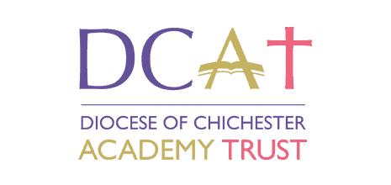
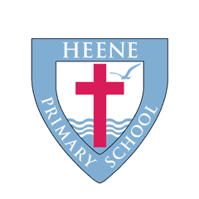
Collective Worship policy

Date agreed | February, 2026
Review date

‘Open doors, warm fires’
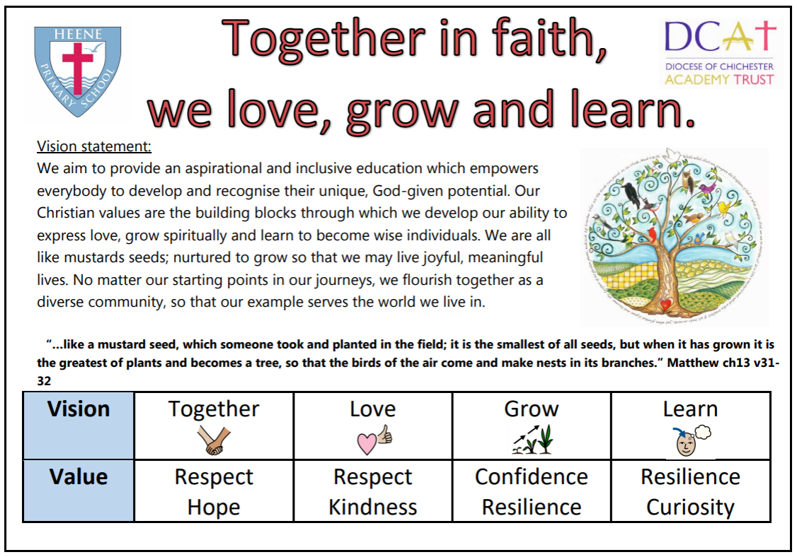
²⁴ And let us consider how we may spur one another on toward love and good deeds, ²⁵ not giving up meeting together, as some are in the habit of doing, but encouraging one another—and all the more as you see the Day approaching. - Hebrews 10: 24-25
Introduction
Collective worship is central to us at Heene Primary School and is one of the vehicles in which pupils and staff learn to express our Christian school values and vision. Collective worship strengthens and supports the Christian ethos and identity of our school, and we aim for our pupils and staff to leave us with a rich experience and understanding of Christianity and of their own place in their spiritual journey. Our worship reflects the variety of traditions found within the Church of England and our parish and follows the Christian liturgical year. The daily act of worship is at the heart of our school and is supported by all staff and governors. It makes an important contribution to the overall spiritual, moral, social and cultural development of our school and celebrates the central role that each person has to play within our school and the wider community.

Aims
Our collective worship is planned:
- to be inspiring, inclusive, invitational and engaging, so that all participants are able to talk about the difference worship makes to their relationships and the life of the school
- around Biblical texts and Christian teaching
- to deepen understanding of our Christian values and vision
- provide opportunities for pupils to express our values
- with a strong focus on God as Father, Son and Holy Spirit, enabling each one of us to embark on an understanding of the Trinity
- to deepen our understanding of Anglican and other Christian traditions found in the UK and worldwide
- to challenge everyone, regardless of background, to understand and embark on their own spiritual journey
- to develop an appreciation and understanding of the value of prayer, reflection and stillness
- to develop a sense of the spiritual, creating opportunities to wonder and respond to something beyond the everyday
- to praise, celebrate and give thanks
- to acknowledge significant achievements and mark significant occasions within the school, local and international community

Legal Requirements
We meet legal requirements by providing a daily act of collective worship which is in line with our Trust and Anglican foundation. The governing Body holds responsibility for ensuring that the legal requirements for worship are met and that all pupils engage each day in a meaningful act of Christian worship. Our daily worship can be whole school worship, key stage, class, group or class lead church services.

Withdrawal from Collective Worship
Parents have the right to withdraw their children from acts of worship. We comply with any request from a parent to withdraw their child. However, in view of the Christian ethos and distinctive Christian character of our school, we expect all children admitted will participate in collective worship, and that anyone wishing to withdraw their child will discuss this with the Headteacher and collective worship co-ordinator before making their decision. Any queries about withdrawal from collective worship should be directed to the collective worship co-ordinator in the first instance and thereafter to the Headteacher. Our distinctive Christian ethos is very important to us and any queries regarding worship for new pupils should be discussed as part of the admission process.

Inclusion and Equal Opportunities
Collective worship is planned to ensure there is an inclusive and adaptive approach to ensure equal opportunity to all pupils, including those with SEN or EAL needs. It is important for our diverse school community to know that they are included, and we celebrate specific days across the year, such as nystagmus day, Dyslexia awareness day and European Languages Day. At Heene primary school, all children embark on a spiritual journey and those who are withdrawn from Worship can have appropriate tasks set for them that allow them to continue to flourish spiritually.

Pattern of Worship
Collective Worship at Henne Primary has a consistent pattern and structure. Within every act of Collective Worship, opportunity for reflection, stillness and prayer is present [appendix a]. Members of our linked Churches are involved in our worship on a regular basis and enrich our worship. We invite visitors to participate in and lead our worship. We liaise with them beforehand so that they are clear about the aims of our collective worship and the need to avoid any proselytising. The Headteacher is consulted before a visiting speaker is confirmed.
Monday – Whole school worship  EYFS, year 1, year 2 , year 3, year 4, year 5 and year 6  Led by the Headteacher | All year groups come together to focus on the key theme of the week as part of the termly focus and associated Christian values.
Tuesday – Class worship  year 1, year 2 , year 3, year 4, year 5 and year 6  Led by the class teacher  Supported by the class worship leader | From year 1 to year 6, Picture News is used to discuss topical issues from around the world. Children are guided through a process of spirituality moments to respond to the question for the week by thinking about God’s message. Pupil’s responses are then celebrated in the classroom spirituality zones.
Wednesday – Sing the faith  EYFS, year 1, year 2 , year 3, year 4, year 5 and year 6  Led by the Music lead | Singing is a passion for us at Heene Primary. We sing hymns or songs that link to our worship theme for the term, practice hymns for our church services and additional songs that link to key dates within the year.
Thursday – Clergy led worship  EYFS, year 1, year 2 , year 3, year 4, year 5 and year 6  Led by member of the Clergy  Supported by Senior Leader Team | We have strong links with our local Churches of St Matthew’s Worthing and St Botolph’s Heene, and the following people are invited to lead Worship.  Paul Taylor - Vicar (church leader, St Matthew’s Worthing)  Nathan Ghinn - Youth and Children’s Work Leader, St Matthew’s, Worthing  Kathryn Flenley – St Botolph’s, Heene
Friday – Shine your light worship  Led by the headteacher  Supported by all class teachers and leaders | Every Friday, we celebrate the achievements of our pupils across the school. We present Shine Your Light certificates to a pupil from each class for demonstrating our Christian Values and Gold Awards at the end of each half term.
Phase leader led worships | Every half term, our phase leaders plan an act of Collective Worship with a creative activity to guide pupils to celebrate and express our Christian Values.
Church Services | Year groups 1 to 6 express our Christin value of confidence to create their own Church service in either St Matthew’s or St Botolph’s.

Planning and monitoring Collective Worship
Collective Worship is part of our daily timetable, and we differentiate acts of collective worship from other assembly activities. We mark this special time with our liturgical opening and closing and by having a pupil light the candle to signify God’s message of peace and hope to all in the room. We use the idea of ‘Open doors, warm fires’ to ensure Collective Worship is invitational for all.
Individuals leading worship are expected to plan the act of worship with the same degree of thoroughness as other planning. We base our acts of worship around a structure of gathering, engaging, responding and sending. Our worship themes follow the liturgical calendar and are planned by our Collective Worship co-ordinator in conjunction with our church links. We draw from a range of resources to supplement our acts of Collective Worship and encourage pupil and staff participation.
The collective worship co-ordinator is responsible for long term planning of worship, supporting staff and pupils who are planning and leading worship, monitoring the quality of worship and evaluating its impact across the school community. Class Teachers currently complete a Collective Worship Monitoring Form every week and the effectiveness of Collective worship is evaluated by the collective worship Co-ordinator and Senior Leadership Team. [appendix b]
Spirituality
At Heene Primary school, we use the candle, mirror, window and door approach towards developing our spirituality journey. Spirituality is not about instilling a specific belief or system of thinking. It is about encouraging all of us to develop a strong sense of self and confidence in our own God-given potential by building on our own personal beliefs, ideas, experiences, desires and hopes for the world. Each week, a key spirituality question is planned in Worship, and children’s responses are captured during a Friday worship. Additional Spirituality Moments are captured during a Tuesday Class Worship. These moments are discussed during the school day, and spirituality moments are captured and placed onto a spirituality zone found in every classroom.

Candle moments – Elicitation  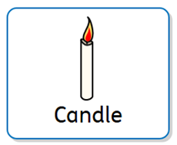  These are moments where we think about and recognise our current beliefs, likes and dislikes and why we do the things that we do.  Questions:  What makes you, you?  What do you believe?  What things do you ‘wonder’ about? | Mirror moments – Reflections  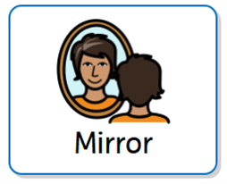  These are moments where we look inward and reflect on our experiences in life. We may consider some of the BIG questions of life and consider some possible answers. To explore their own insights and those of others.  Questions:  Have you ever experienced this in your life?  What qualities or values do you think are the most important?
Window moments - Encounter  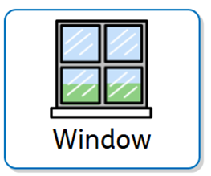  These are moments where we look out into the world to learn, enjoy, gaze and become aware of the world in new ways. We might think about ‘WOWs’ (things that amaze us) and ‘OWS’ (things that worry or upset us).  Questions:  What amazing things have you seen in the world?  Have you seen any WOW or OW moments? | Door moments - Transformation  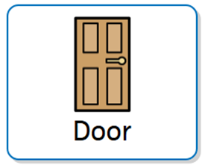  These are moments where we respond to something by putting into action. We believe we are all capable of making a difference in the world. We foster a spirit of agency and engagement with the world we live in and think of ways to become courageous advocates.  Questions:  What difference could you make in the world?  What could you do to achieve this hope?

Community
We have strong community links with our local churches, St Matthew's Worthing and St Botolph’s, Heene. Years 1 to 6 have an opportunity to conduct their own Church service at these churches on a key Christian theme linking to the Christian calendar where their families and the whole school are invited to attend. Children contribute to displays in these churches, write cards, messages of thanks and prayers.
Worship leaders
At least one pupil from each class in Key Stage 1 and Key Stage 2 has the opportunity to become a worship leader each year. Their role is to support those leading worship, celebrating the Christian values and vision of our school by handing out Silver Awards and are met with on a regular basis to gain pupil feedback on Collective Worship. Worship Leaders understand the importance of becoming courageous advocates for our school and suggest ways in which pupils at Heene Primary may contribute to the school and wider community.

This policy will be assessed annually both in terms of its implementation and effectiveness. In reviewing the policy, the Governing Body will be mindful of the views of parents, students and staff through a variety of consultations.

The impact of our collective worship is independently inspected by law under Section 48 of the Education Act 2005.

This policy has been adopted by the Governors/Directors in consultation with the senior leaders, the CW leader and teaching staff.

This policy should be read in conjunction with other policies.

Date of adopted: February, 2026

Date of review……………………….

Appendix A:
The lighting of the candle  (Kindness, Hope, Curiosity) | Liturgical response: Peace be with you. And also with you.  Why this is done:  We start worship by being together. We invite God into our hearts by spreading a feeling of peace to one another.  Jesus symbolises the ‘light’ that guides and inspires us. "I am the Light of the world; the one who follows me will not walk in darkness, but will have light and life" (John 8:12),” It shows reverence and our desire to remain present.  Light is often associated with knowledge, wisdom and spiritual enlightenment. Candles, with their gentle glow, symbolize the search for truth, clarity and inner illumination.  A child should come to the front to do this.
Main message  (Curiosity, Respect) | The main parts of the collective worship will discuss a Christian theme or idea.  The following are examples that can be used to deliver this message:  - Bible stories and parables  - Verses from the bible.  - Worship songs  - Events in the world  - An item or object to inspire awe and wonder.  - Drama  - Video or interactive media
Song /Hymn  (Confidence) | The song or Hymn will relate to the Liturgical calendar or theme of worship. This is the moment children at Heene find the most joy is expressed through singing Christ’s message.
Spirituality moment  (Kindness, Hope, Respect, Resilience) | This allows us to take some time to react to the idea or theme discussed within the worship. We should be thinking about our own lives and how this idea or theme relates to us.  We also think about becoming courage advocates and how we can use this message to improve the world and the lives of others around us.  - Candle moment  - Window moment  - Door moment  - Mirror moment
Prayer  (Respect, Hope, Kindness, Resilience) | A prayer will complete the worship where everyone comes together.  Prayer is a personal experience where people express their thoughts and feelings through communicating with God in their own way. Hands may come together or bowed heads.  The prayer itself can be one that links to the idea or theme discussed, a specific prayer, the Lord’s prayer, or a prayer created by someone in the room.  Candle link: The light of the candle signifies our prayer, which is offered in faith, entering the light of God.
The candle is extinguished  (Kindness, Hope) | Liturgical response: Go in peace to love and serve the lord. In the name of Christ Amen.  Peace is blessed on everyone which demonstrates our kindness and hope for one another. A child should come to the front to do this.
Appendix B:
Collective worship moderation form
Date ___ / ____ / _____
Worship lead by:
Inspiring | Invitational | Inclusive
How did the worship inspire children and staff?  What was the message / takeaway from the worship?  Is everyone inspired to become courageous advocates? | Were children and staff given the opportunity to engage?  Warm fires and open  Doors. | How were all children and staff included within the worship?  Were they all able to access it despite their different stages in their spiritual journey?
Gathering – Inclusive
- How did the leader welcome the everyone, set the scene and create an inclusive atmosphere?
- Were people ‘together’ with pupil or staff participation?
Engaging – Inspiring / Inclusive
- What methods were used to engage everyone? Story, drama, music awe and wonder…
- Was the main input engaging and thoughtful?
- Were the pupils and staff engaged?
Responding – Invitational
- Was there an opportunity for pupils to respond to the main input through reflection/prayer or something else?
- Was everyone allowed to participate in a way that was by choice?
- Was time given for stillness to allow everyone to reflect or communicate with God?
Sending – Inspiring
- Were people sent out with a sense of purpose: to make a difference in the world; love and serve one another?
- Were people sent out with a sense of God’s blessing?
- What was the message everyone took away with them?

Any further comments:

