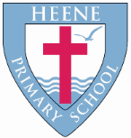
Heene CE Primary School
‘Together in faith, we love, grow and learn.’

Collective worship process
The lighting of the candle  (Kindness, Hope, Curiosity) |   Liturgical response  Why this is done:  We start the worship by being together. We invite God into our hearts by spreading a feeling of peace to one another.  Jesus symbolises the ‘light’ that guides and inspires us. "I am the Light of the world; the one who follows me will not walk in darkness, but will have light and life" (John 8:12),” It shows reverence and our desire to remain present.  Light is often associated with knowledge, wisdom and spiritual enlightenment. Candles, with their gentle glow, symbolize the search for truth, clarity and inner illumination.  A child should come to the front to do this.
Main message  (Curiosity, Respect) | The main parts of the collective worship will discuss a Christian theme or idea.  The following are examples that can be used to deliver this message:  - Bible stories and parables  - Verses from the bible.  - Worship songs  - Events in the world  - An item or object to inspire awe and wonder.  - Drama  - Video or interactive media
Song /Hymn  (Confidence) | The song or Hymn will relate to the Liturgical calendar or theme of the worship. This is the moment children at Heene find the most joy is expressed through singing Christ’s message.
Spirituality moment  (Kindness, Hope, Respect, Resilience) | This allows us to take some time to react to the idea or theme discussed within the worship. We should be thinking about our own lives and how this idea or theme relates to us.  We also think about becoming courage advocates and how we can use this message to improve the world and the lives of others around us.  - Candle moment  - Window moment  - Door moment  - Mirror moment
Prayer  (Respect, Hope, Kindness, Resilience) | A prayer will complete the worship where everyone comes together.  Prayer is a personal experience where people express their thoughts and feelings through communicating with God in their own way. Hands may come together or bowed heads.  The prayer itself can be one that links to the idea or theme discussed, a specific prayer, the Lord’s prayer or a prayer created by someone in the room.  Candle link: The light of the candle signifies our prayer, which is offered in faith, entering the light of God.
The candle is extinguished  (Kindness, Hope) | 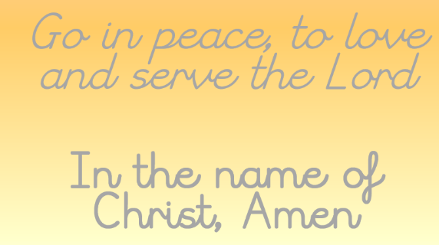  Liturgical response  Peace is blessed on everyone which demonstrates our kindness and hope for one another. A child should come to the front to do this.

